Sector Counts

- Sector Coverage and Counts
SELECT
Sector,
COUNT(*) AS n,
COUNTIF(price IS NULL OR price <= 0) AS bad_price_rows
FROM `projectspractice12.sp500dataAnalysis.sp500data`
GROUP BY sector
ORDER BY n DESC;

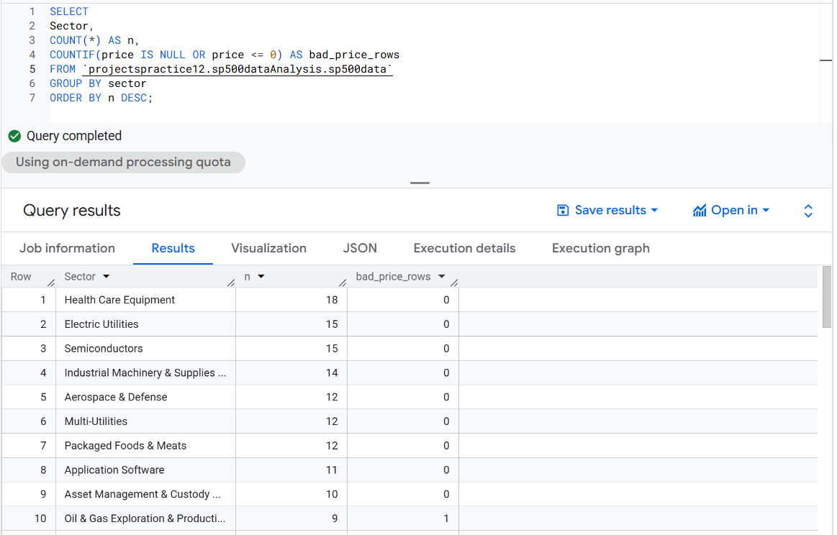
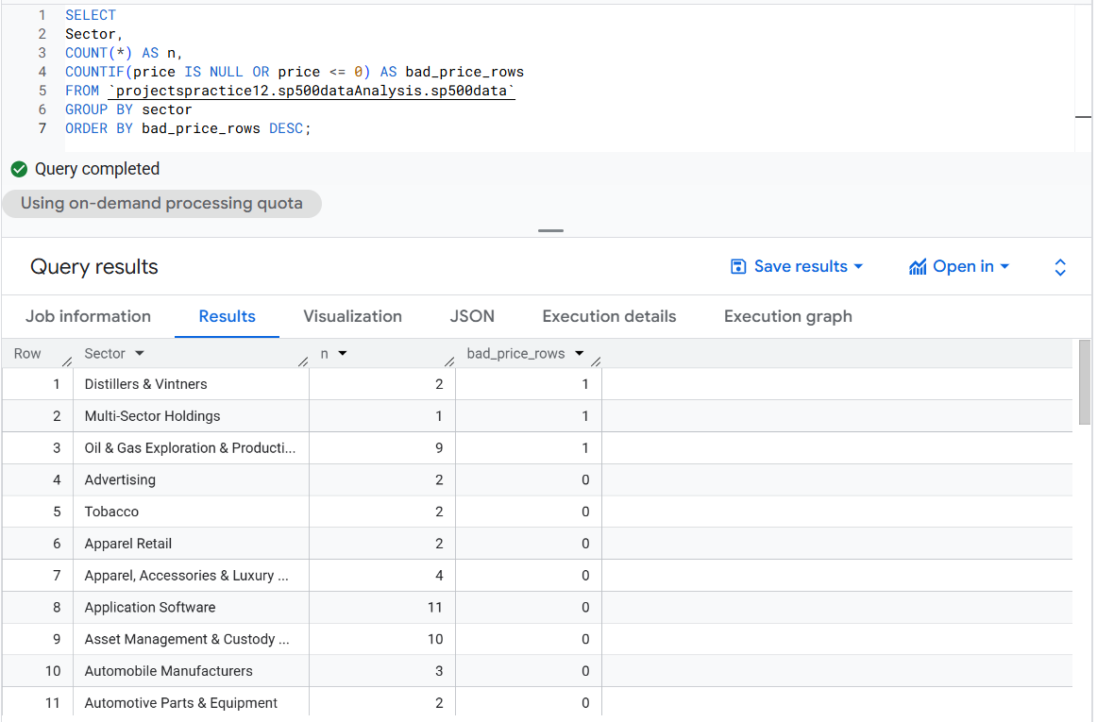

Distribution Profiling

SELECT
APPROX_QUANTILES(priceToEarnings, 10) AS pe_deciles,
APPROX_QUANTILES(ebitda, 10) AS ebitda_deciles,
APPROX_QUANTILES(dividendYield, 10) AS divy_deciles,
APPROX_QUANTILES(PriceToSales, 10) AS ps_deciles,
APPROX_QUANTILES(priceToBook, 10) AS pb_deciles,
APPROX_QUANTILES(marketCap, 10) AS mktcap_deciles
FROM `projectspractice.sp500dataAnalysis.sp500data`;
